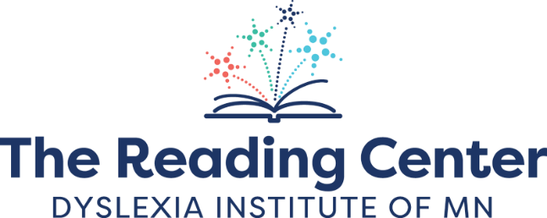

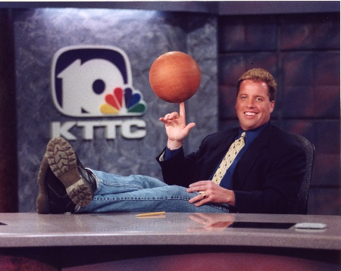
Pat Lund Memorial Post-Secondary Scholarship
Patrick “Pat” Lund (1963-2022) was a Reading Center alumnus who was a thirty-year fixture in the Southeastern MN sports reporting field. Most of his career was spent at KTTC-TV in Rochester. He had a legacy of mentoring younger television journalists and photojournalists and was the second inductee into the Tight End Hall of Fame in 2021. Despite being held back in 1st grade and struggling through high school and college, Pat persevered and worked in his dream career as a sports reporter. Pat didn’t let his dyslexia stop him from achieving his goals.
The Lund family is celebrating Pat by helping others with dyslexia to reach their goals. The Lund family, in partnership with The Reading Center, has created an annual scholarship in his honor to help dyslexic students reach their post-secondary education goals. This opportunity is open to The Reading Center alumni up to age 30 who are currently enrolled or have confirmed plans to continue their education through a university, technical school or other training program during the 2024-25 school year. Scholarship awards are for up to $1,000 per year, will be paid directly to the school and are renewable for up to 4 years if studies are continued.
Who Can Apply
This opportunity is open to any dyslexic Reading Center current or past 1:1 tutoring student or class participant (such as Best of Basics summer program) who is 30 years old or younger and who will be enrolled in a post-secondary undergraduate education program such as a 4-year university, 2 year technical program, or other training program during the 2024-25 school year. Students starting a program and those who are partially through their education are invited to apply.
How it Works
One recipient annually will be selected to receive up to a $1,000 scholarship award, renewable up to 4 years as long as a recipient is enrolled in the program (not to exceed $4,000 per recipient). Payments will be made directly to the educational institution. Award decisions will be made by a panel selected by The Reading Center along with a member of the Lund family.

Important Dates
Application Process Opens: February 1, 2024
Application Deadline: April 15, 2024
Award Announcement: By May 15, 2024
Award Presentation at The Reading Center Board Meeting: May 29, 2024, or June 26, 2024, 6 pm (local recipients invited in-person to The Reading Center in Rochester)
How to Apply
Applicants are invited to fill out this application form and answer two short essay questions a Google form. The essay questions may be submitted in written form or recorded as a video essay. Questions and essay topics included in the application:
First Name
Last Name
Date of Birth
Permanent Address
Phone Number
Email
Pronouns (optional)
Race (optional)
Services received/ programs participated at The Reading Center (ie. Testing, 1:1 tutoring, BoB)
Year (s) attended The Reading Center (if you need help identifying dates of service at TRC, please contact Zhade at read@thereadingcenter.org or 507-288-5271)
The Reading Center Tutor(s)
High School Name
High School Graduation Year
Post-Secondary Education opportunity you will be enrolled in during Fall 2024 (School name & specific program of study)
Are you currently enrolled in this program? If so when did you start?
Estimated length of program (if you are partially through the program, please list the number of years you have left to complete)
Program Tuition Cost per year (prior to scholarships or financial aid)
Extra-Curricular Activities: Please attach a resume of no more than 2 pages or a list current community involvement, athletic activities, employment, and hobbies. )
Optional Photos: Please share up to 3 photos of you engaged in community, athletic activities, employment, and or hobbies.
Essay Question #1: Why are you pursuing this educational program, and how do you plan to use your education and career path to make an impact in your field of study or larger community?
Essay Question #2: How has dyslexia challenged you, and how have you adapted or grown because of it?
(Essay questions may be answered in written form, on 1 page or under for each question/ 250-500 words or as a video of no more than 6 minutes total for both questions. Applicants are reminded that it is OK and encouraged to have a friend, teacher, or family member proofread your application before submission )
For more information or questions, please contact Jamie at jschwaba@thereadingcenter.org

